Network Security
Learning Objectives
- Introduce network Security
- Explain types of network Security
- Firewall protection, E-Mail, Antivirus, Virtual Private Network
- common network security threats
Introduction to Network Security
Network security is the practice of protecting a computer network from unauthorized access, misuse, or attacks. Any action intended to safeguard the integrity and usefulness of your data and network is known as network security.
It involves using tools, technologies, and policies to ensure that data traveling over the network is safe and secure, keeping sensitive information away from hackers and other threats.
The most basic example of Network Security is password protection which the user of the network chooses. In recent times, Network Security has become the central topic of cyber security with many organizations inviting applications from people who have skills in this area.
Types of Network Security
Firewall Protection
A firewall is a network security device either hardware or software-based which monitors all incoming and outgoing traffic and based on a defined set of security rules it accepts, rejects, or drops that specific traffic. It acts like a security guard that helps keep your digital world safe from unwanted visitors and potential threats.
Before Firewalls, network security was performed by Access Control Lists (ACLs) residing on routers. ACLs are rules that determine whether network access should be granted or denied to specific IP address. But ACLs cannot determine the nature of the packet it is blocking. Also, ACL alone does not have the capacity to keep threats out of the network. Hence, the Firewall was introduced. Connectivity to the Internet is no longer optional for organizations. However, accessing the Internet provides benefits to the organization; it also enables the outside world to interact with the internal network of the organization. This creates a threat to the organization. In order to secure the internal network from unauthorized traffic, we need a Firewall.
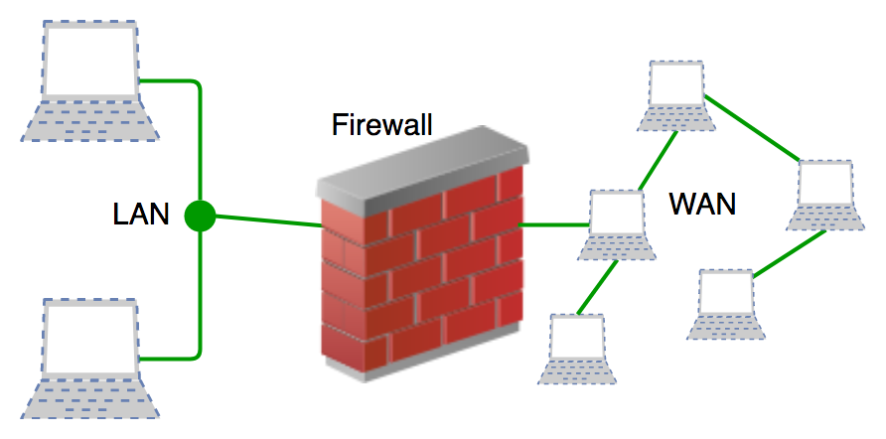

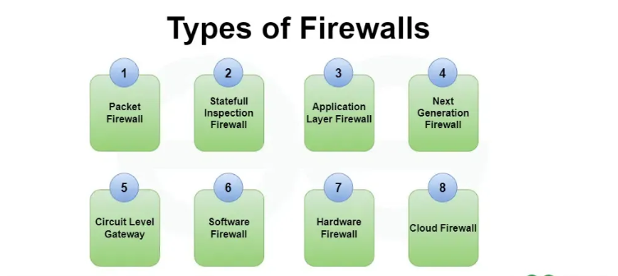

Email
Email security involves protecting email accounts, content, and communications from unauthorized access, loss, or compromise. It involves using strong authentication methods like multi-factor authentication (MFA), encryption to secure email content, and spam filters to block malicious emails. Additionally, implementing technical protocols such as SPF, DKIM, and DMARC helps prevent email spoofing and phishing attacks. Regular user awareness training and software updates also play a crucial role in enhancing email security, ensuring that organizations and individuals remain protected against evolving cyber threats.
Antivirus for network security
Antivirus software plays a crucial role in network security by detecting, preventing, and removing malicious software (malware) that could compromise systems within a network. It helps protect devices, data, and communications from threats such as viruses, worms, ransomware, spyware, and trojans.
How Antivirus Enhances Network Security??
- Threat Detection & Removal
- Scans files, emails, and downloads for known malware signatures.
- Uses heuristic analysis to identify new or modified malware.
- Real-Time Protection
- Monitors network traffic for suspicious activities.
- Blocks malicious websites and harmful downloads.
- Firewall Integration
- Works alongside firewalls to filter network traffic.
- Prevents unauthorized access to network resources.
- Endpoint Security
- Protects all devices (PCs, laptops, mobile phones) connected to the network.
- Prevents infected devices from spreading malware to others.
VPN (Virtual Private Network)
A Virtual Private Network (VPN) is a technology that encrypts internet traffic and routes it through a secure server, masking a user's IP address and ensuring privacy and security while browsing online. VPNs are widely used for enhancing security, bypassing geographic restrictions, and protecting sensitive data from cyber threats.
How VPN Works??
Data Encryption – A VPN encrypts data before it leaves your device, making it unreadable to hackers and ISPs (Internet Service Providers).
IP Masking – Your real IP address is hidden, and websites see the VPN server’s IP instead, enhancing anonymity.
Secure Tunneling – Data travels through an encrypted "tunnel" to a VPN server, ensuring privacy and preventing unauthorized interception.

Network Access Control (NAC)
Network Access Control (NAC) is a security solution that enforces policies to control access to a network based on the compliance and security posture of devices and users. NAC systems are designed to prevent unauthorized access, ensure that devices meet security standards, and protect network resources from potential threats.
Key Components of NAC:
1. Authentication: Verifies the identity of users and devices attempting to access the network.
2. Authorization: Determines what resources and services the authenticated users and devices are allowed to access.
3. Endpoint Security: Ensures that devices comply with security policies (e.g., up-to-date antivirus, firewalls, and patches) before granting access.
4. Quarantine and Remediation: Isolates non-compliant devices and provides mechanisms to bring them into compliance.
5. Monitoring and Reporting: Continuously monitors network activity and generates reports for compliance and auditing purposes.
Types of NAC:
1. Pre-Admission NAC: Controls access before a device is allowed to connect to the network. This typically involves checking the device's security posture before granting access.
2. Post-Admission NAC: Monitors and controls devices after they have been granted access to the network, ensuring they continue to comply with security policies.
Benefits of NAC:
- Enhanced Security: Reduces the risk of unauthorized access and potential security breaches.
- Compliance: Helps organizations meet regulatory requirements by enforcing security policies.
- Visibility: Provides detailed insights into all devices connected to the network.
- Automated Response: Automatically isolates or remediates non-compliant devices, reducing the need for manual intervention.
Common NAC Solutions:
- Cisco Identity Services Engine (ISE)
- Aruba ClearPass
- Forescout
- Pulse Policy Secure
- FortiNAC
NAC is a critical component of a comprehensive network security strategy, helping organizations protect their networks from both internal and external threats.
Common Network Security Threats
Network security threats are constantly evolving as technology advances and attackers develop new methods to exploit vulnerabilities. Here are some common network security threats that organizations and individuals face:
- Virus
A computer virus is a type of malicious software (malware) that attaches itself to legitimate programs or files and spreads from one system to another. It requires human interaction (e.g., opening an infected file or program) to execute and replicate.
How It Works:
- A virus typically infects a host file or program.
- When the infected file is executed, the virus code runs and can perform malicious actions, such as corrupting files, stealing data, or spreading to other files or systems.
- Viruses often spread via email attachments, infected software downloads, or removable media like USB drives.
- Torjan (Torjan Horse)
A Trojan is a type of malware that disguises itself as legitimate software or files to trick users into installing it. Unlike viruses, Trojans do not replicate themselves but instead create backdoors for attackers to gain unauthorized access to systems.
How It Works:
- Trojans are often hidden in seemingly harmless files, such as games, software installers, or documents.
- Once executed, they can perform malicious actions, such as stealing data, installing additional malware, or giving attackers remote control over the infected system.

Characteristics:
- Deception: Trojans rely on social engineering to trick users into running them.
- No Self-Replication: Unlike viruses, Trojans do not spread on their own.
- Backdoor Access: Many Trojans create a backdoor for remote attackers.

- Computer Worm
A computer worm is a standalone malware program that replicates itself to spread to other systems, often without human interaction. Worms typically exploit network vulnerabilities to propagate.
How It Works:
- Worms spread by exploiting vulnerabilities in operating systems, software, or network protocols.
- They can spread via email, instant messaging, file-sharing networks, or network connections.
- Once a worm infects a system, it can perform malicious actions, such as deleting files, consuming bandwidth, or creating backdoors.
Characteristics:
- Self-Replication: Worms replicate themselves to spread rapidly across networks.
- No Host File Required: Unlike viruses, worms do not need to attach themselves to other files.
- Network-Based Propagation: Worms often spread through network connections.

- Phishing Attacks
Phishing is a type of social engineering attack where attackers impersonate legitimate entities to trick individuals into revealing sensitive information, such as passwords, credit card numbers, or personal data.
How It Works:
- Attackers send fraudulent emails, messages, or websites that appear to be from trusted sources (e.g., banks, social media platforms, or companies).
- The goal is to lure victims into clicking on malicious links, downloading attachments, or entering sensitive information on fake websites.
Characteristics:
- Deception: Phishing relies on social engineering to manipulate victims.
- Urgency: Messages often create a sense of urgency (e.g., "Your account will be locked!").
- Spoofing: Attackers spoof email addresses, websites, or phone numbers to appear legitimate.

